Occupational Health and Safety Procedures Manual

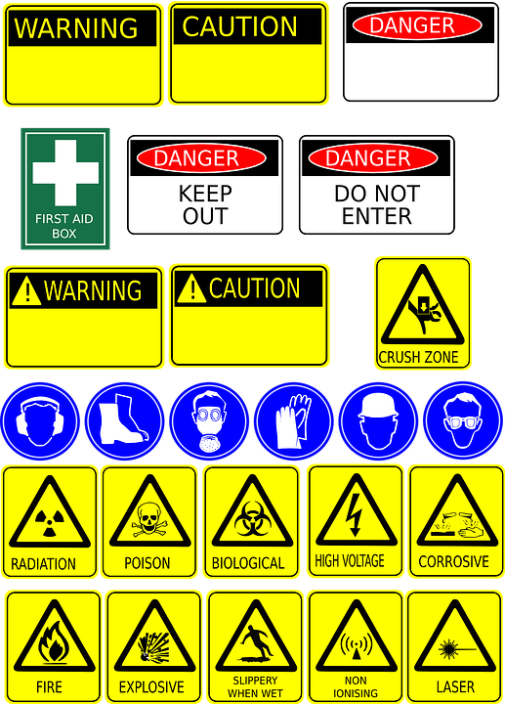

Contents

Section 1 Occupational Health and Safety
- OH&S Policy
- Incident and Injury Report Form
- Hazard Report Form
- Risk Management
- OH&S Guidelines & Protocols

Section 2 Smoking Policy
- KBC Policy
- Designated Smoking Areas

Section 1: Occupational Health and Safety

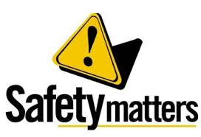

Occupational Health and Safety Policy

PURPOSE:
Keilor Bowls & Community Club is committed to ensuring the safety, health and wellbeing of its employees, members, contractors and visitors through the provision of a safe workplace and environment.
This policy applies to all employees, members, visitors, volunteers and contractors.

GUIDELINES:
Keilor Bowls & Community Club
- recognises that health and safety is integral component of Club culture
- is committed to providing employees, members, contractors and visitors with a healthy and safe working and sporting environment
- will so far as is reasonably practicable, take action to improve and promote Occupational Health and Safety (OHS) to prevent injuries and illnesses within the club environment
RESPONSIBILITES:
In the promotion of a safe workplace and environment, Keilor Bowls & Community Club will:
- consult with staff and members so far as reasonably practicable on OHS decisions and changes that affect their workplace and environment
- identify and reduce OHS risks through a documented process of hazard identification, assessment, implementation and review of controls
- comply with relevant legislation, procedures and guidelines relating to OHS
- maintain, monitor and review the OHS Management System to ensure so far as reasonably practicable it is compliant and to drive continuous improvement
- provide appropriate OHS information and training for employees in order to provide a safe and supportive workplace to meet legislative obligations
- report and investigate incidents where appropriate, and act to prevent re-occurrence.

In the promotion of a safe workplace and environment, employees, members, visitors, and contractors are required to:
- take reasonable care for his or her own health and safety
- take reasonable care that their acts or omissions do not adversely affect the health and safety of other persons
- comply with any reasonable instructions that is given by a person in authority regarding OH&S
- actively contribute to identifying, reporting and reducing OHS hazards and risks

INCIDENT REPORTING:
All incidents, injuries or hazards must be reported on the appropriate forms.
These are available on the Keilor Bowls & Community Club website or in hard copy from the Secretary
Completed forms will go to the Board of Management for appropriate action.

Authorised by: Management Committee

Date: 6th May 2021

Incident/Injury Report Form
Report to be completed by person involved or Management Committee Member if person is incapacitated.

Section 1: Person’s details
Family name |  | First name
Address |  | Contact Number
Describe the Incident
Date / / Time am/pm |  | Reported to Date / /
Near miss (a dangerous incident without injury to person or damage to property). Go to Section 2

Accident (an incident resulting in injury to a person or damage to property). Complete Sections 2,3 & 4

Section 2: Incident details (attach an extra page if necessary)
Where did it happen?
Describe how it happened
Why do you think it happened and what, if any, controls can be implemented to help ensure the incident doesn’t happen again?

Section 3: Witnesses
Were there any witnesses to the injury? | Yes / No (Please circle your response)
If yes, please list the witnesses’ full names as well as a contact number for each.
Section 4: Injury and Medical
Describe the injury
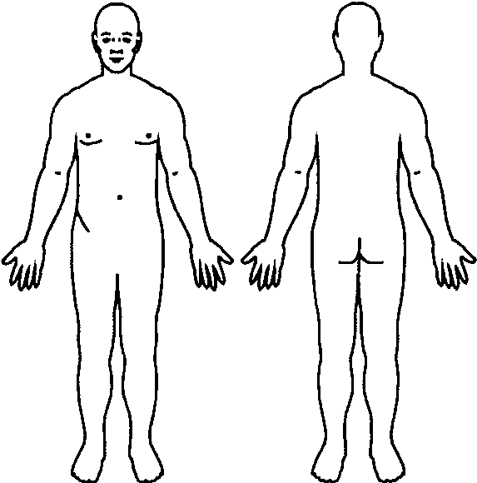
Describe and mark on diagram bodily location of injury
Or list any damage to property

Was any first aid provided? | Yes / No (Please circle your response)
If yes, please provide details.
Did the injured person require an Ambulance? | Yes / No (Please circle your response)
Was the injured person transported to Hospital? | Yes / No (Please circle your response)

Section 5: To be completed by the Investigating Officer
Has an investigation been conducted into the incident and by who?  Name of the person who conducted the investigation. |  | Yes / No
Have the controls been implemented? | Yes / No Date / /
Name  Signature and Date | Date / /
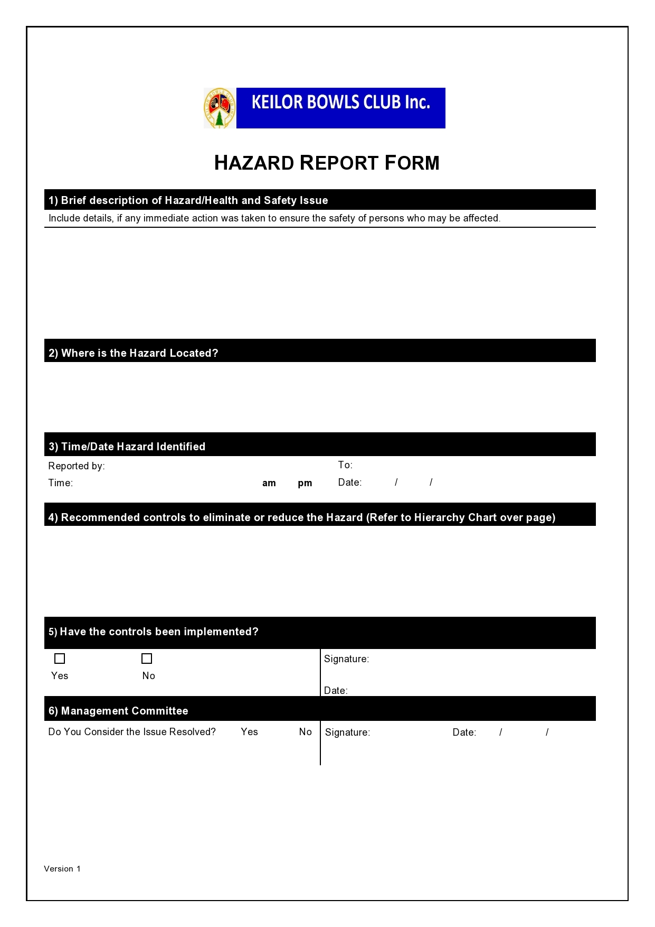

Risk Assessment

Hazard Identification
Form completed by: Hazard:
Date: / /
Associated Risk/s:
Signature:

Risk Assessment (Refer to Descriptors)
Existing control measures (if any)
Likelihood: Almost certain Likely Possible Unlikely Rare
Consequences: Catastrophic Major Moderate Minor Insignificant
Risk Control
Possible control options:
Elimination, Substitution, Engineering, Administrative or Personal Protective Equipment:
Preferred control option/s:

Control option | Resources required | Person(s)  responsible | Implementation  date | Sign off and date | Scheduled review  date

Implementation Plan

Are control measures in place? Yes/No

Are they sufficient Yes/No (If no complete recommendation/s)

Recommendation/s:

Name: Signature:

Date / /

OH&S Guidelines & Protocols

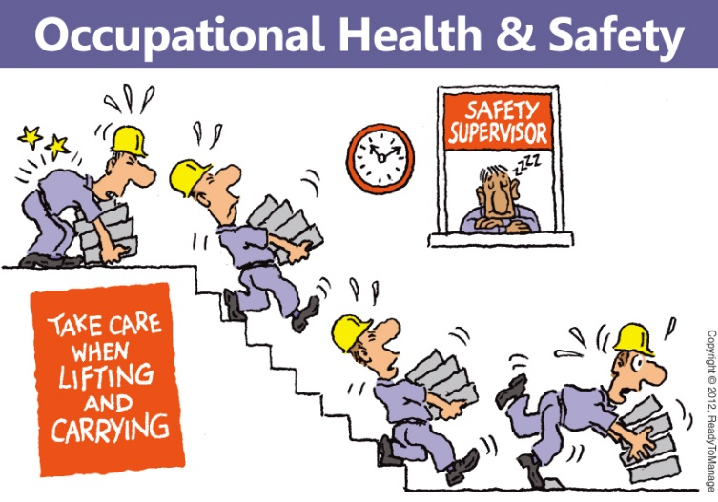

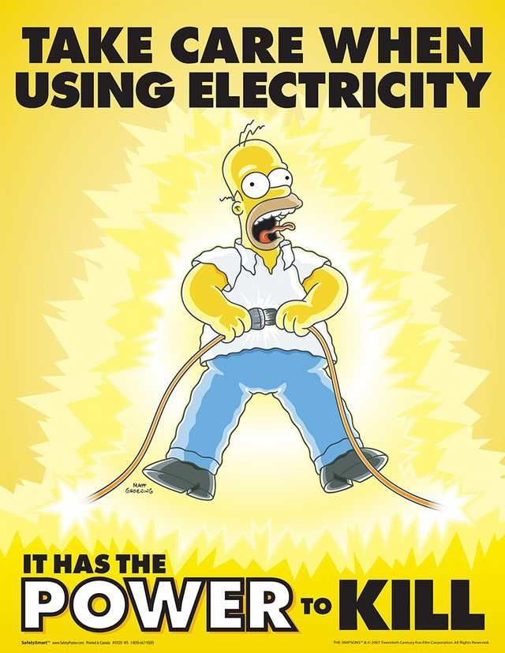
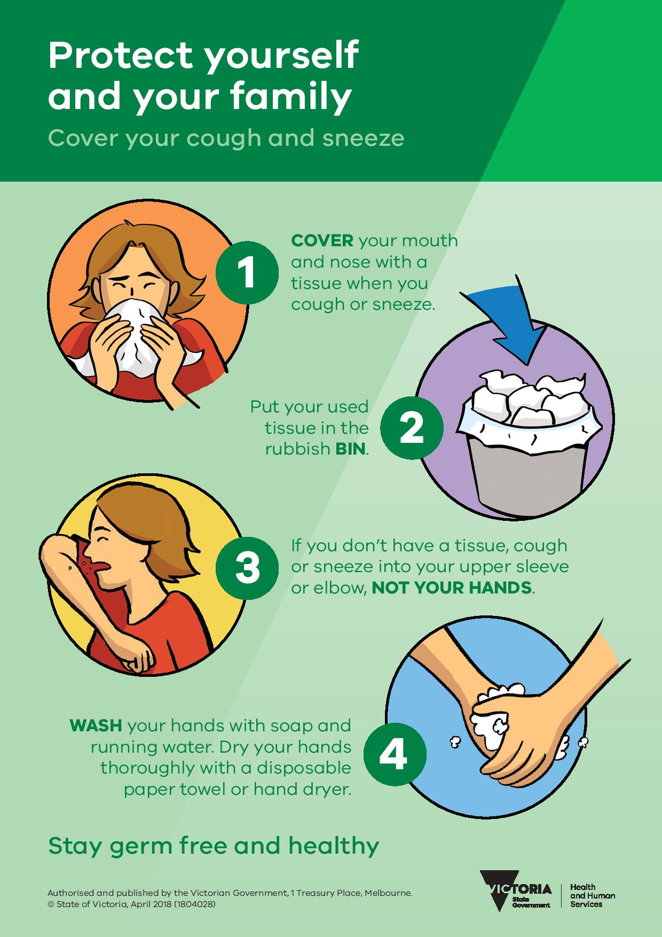
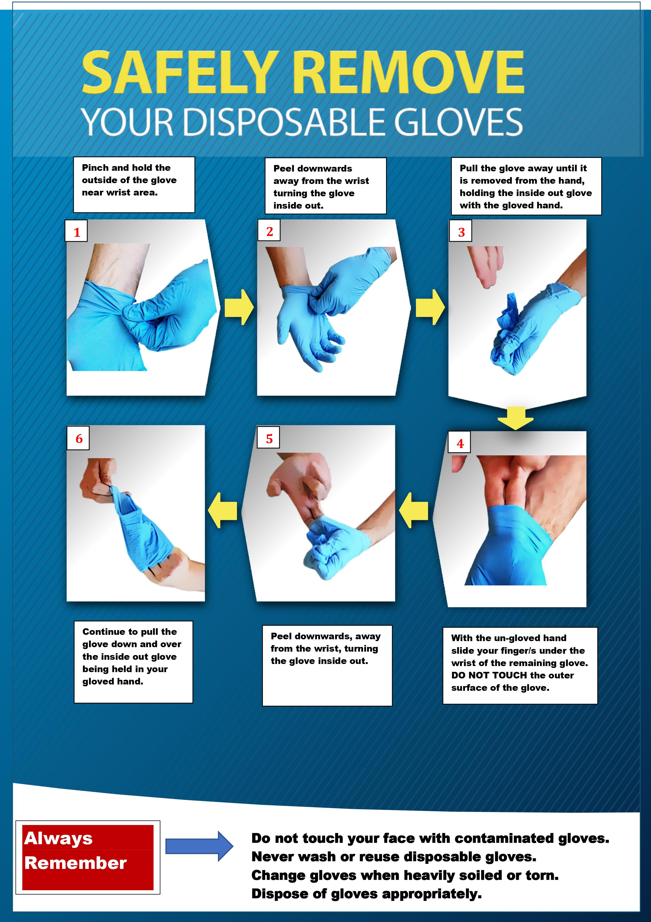
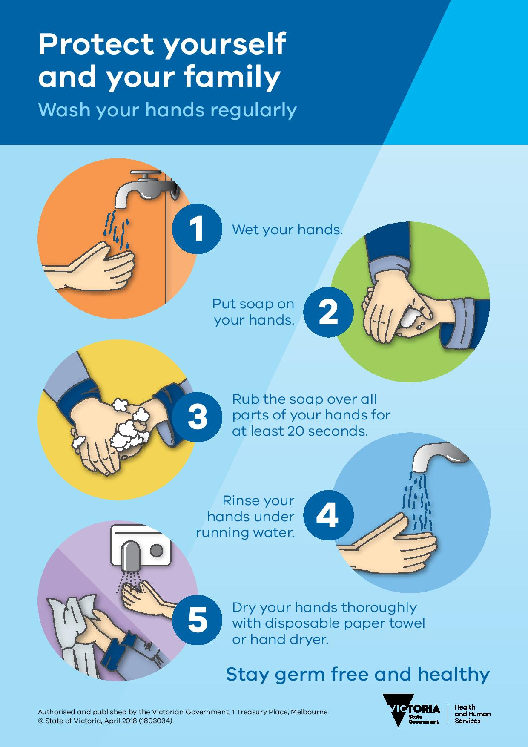
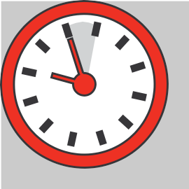
Take Five for Safety!!!!!!!!

Identify AND control hazards before you start work.
- Stop, look, walk around the task 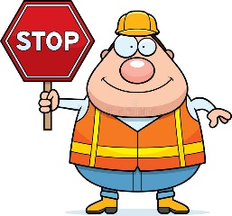
- Think about the task, have a clear plan
- Identify and assess hazards that exist or may be created by the task and rate their risk levels
- Control the risks and communicate
- Do the task if low risk and keep a lookout for changes

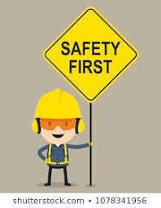
Take Five – prove it safe
before you start work

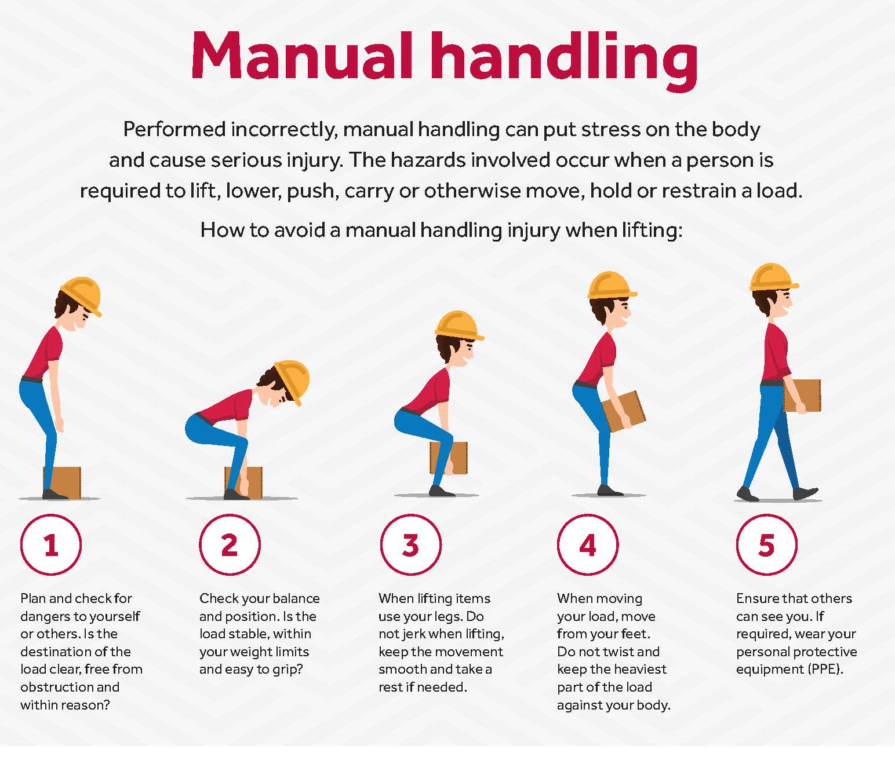

Common Manual Handling Risks
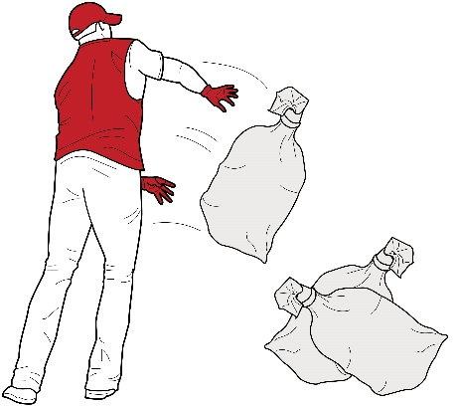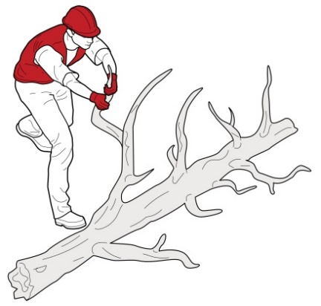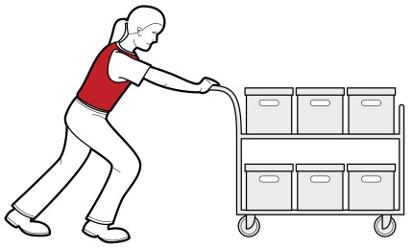

Movement High Force Sustained Force
Repetitive movement- using the same parts of the body to repeat similar movements over a period of time.
Sustained force- occurs when force is applied continually over a period of time.
High force-occurs when increased muscle effort is required in response to a task.

Health and Hygiene
Protocols for Cleaning Staff

In the interest of your safety, that of others and to reduce the risk of spread of disease the following protocols are to be implemented immediately. Should you have any concerns or queries please contact the Management Committee.

General

- All Cleaning Staff to wear disposable gloves.
- All areas to be cleaned must be sanitised, using cleaning agents and/or hot water and detergent.

Removal and disposal of gloves.

- The outside of the gloves is contaminated.
- Remove gloves being careful not to contaminate bare hands during the process. (Refer to the How to Guide)
- Dispose of the gloves appropriately.
- Wash your hands with either liquid soap and hot running water or alcohol-based hand rub.

A How-To Guide for the Removal (Doffing) of Disposable Gloves

- Pinch and hold the outside of the glove near the wrist area.

- Peel downwards, away from the wrist, turning the glove inside out.

- Pull the glove away until it is removed from the hand and hold the inside-out glove with the gloved hand.

- With your un-gloved hand, slide your finger/s under the wrist of the remaining glove, taking care not to touch the outside of the glove.

- Again, peel downwards, away from the wrist, turning the glove inside out.

- Continue to pull the glove down and over the inside-out glove being held in your gloved hand. This will ensure that both gloves are inside out, one glove enveloped inside the other, with no contaminant on the bare hands.

Health and Hygiene
Protocols for Bar Staff

In the interest of your safety, that of others and to reduce the risk of spread of disease the following protocols are to be implemented immediately. Should you have any concerns or queries please contact the Management Committee.

General

- All glasses are to be washed using cleaning agents and/or hot water and detergent.
- All wet areas, at the close of business, are to be sanitised using cleaning agents and/or hot water and detergent.
- Disposable Gloves are to be worn when using cleaning agents.

Removal and disposal of gloves.

- The outside of the gloves is contaminated.
- Remove gloves being careful not to contaminate bare hands during the process. (Refer to the How to Guide)
- Dispose of the gloves appropriately.
- Wash your hands with either liquid soap and hot running water or alcohol-based hand rub.

A How-To Guide for the Removal (Doffing) of Disposable Gloves

- Pinch and hold the outside of the glove near the wrist area.

- Peel downwards, away from the wrist, turning the glove inside out.

- Pull the glove away until it is removed from the hand and hold the inside-out glove with the gloved hand.

- With your un-gloved hand, slide your finger/s under the wrist of the remaining glove, taking care not to touch the outside of the glove.

- Again, peel downwards, away from the wrist, turning the glove inside out.

- Continue to pull the glove down and over the inside-out glove being held in your gloved hand. This will ensure that both gloves are inside out, one glove enveloped inside the other, with no contaminant on the bare hands.

Section 2: Smoking Policy

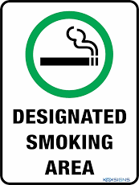

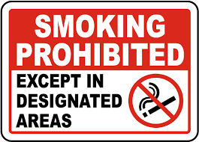

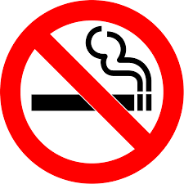

Smoking and Vaping Policy
PHILOSOPHY

Keilor Bowls & Community Club recognises the importance of health and fitness and reducing the exposure of members, visitors and contractors to potentially harmful situations. Keilor Bowls & Community Club also recognises that exposure of non-smokers to environmental tobacco smoke is hazardous to health and that non-smokers should be, as far as practicable protected from this.
Having this smoking policy will help to protect the health of members, contractors, and visitors by reducing the risk of exposure to environmental tobacco & vaping smoke. It will also assist Keilor Bowls & Community Club to comply with their duty of care.

Authorised by: Management Committee

Date: 10/02/2021

Smoking & Vaping Policy

Keilor Bowls & Community Club Inc
Mission Statement
Keilor Bowls & Community Club:
- is committed to providing members, contractors and visitors with a safe, healthy and supportive environment
- recognises that the health and wellbeing of our members, contractors and visitors is important
- is committed to providing a supportive club culture where healthy lifestyle choices are valued and encouraged.

Objectives and Strategies
- Keilor Bowls & Community Club will by the implementation of this policy assist to safeguard members, contractors and visitors from environmental tobacco smoke.
- This policy will not infringe upon the rights of smokers.
- This policy does not ban cigarettes but simply limits their use in certain areas.
Scope and Application
- Smoking and vaping is not permitted at Keilor Bowls & Community Club any time during except within the designated smoking areas
- The designated smoking areas are identified with ‘Designated Smoking Area’ signs.
- This policy applies to all persons while on Keilor Bowls & Community Club premises.
- For Bowls Victoria Governed Events this Policy is superseded by Bowls Victoria Smoke Free Policy Version1/2018.
- For events where Bowls Australia is the Controlling Body this Policy is superseded by Bowls Australia Policy Title: Smoke Free and Alcohol Policy/2017
- This policy was endorsed by the Committee of Management on 10/2/21 and applies from 1st March 2021 until further notice.
- This policy applies to both tobacco products and also electronic cigarettes.

In addition:
- Cigarette sales and/or promotion of cigarette products is not permitted on Club premises.

Compliance Measures
- All members, contractors and visitors are required to comply with the requirements of this policy.
- All members are responsible for ensuring their visitors comply with this policy.
Communication
Keilor Bowls & Community Club will ensure that:
- this policy is easily accessible by all members, contractors and visitors
- members and contractors will be made aware of any changes to this policy.

Designated Smoking & Vaping Areas

Keilor Bowls & Community Club

